KIIT SAP Capstone Project
Employee Master Data ALV Report
Real ABAP Development Scenario

1. Problem Statement
Human Resources departments in large enterprises manage thousands of employee records spread across multiple SAP info types. Extracting a consolidated, filterable, and management-ready view of employee master data combining organizational assignment, personal details, and compensation typically requires navigating several SAP transactions separately. This is time-consuming and error-prone.

The objective of this project is to develop a Custom ALV (ABAP List Viewer) Report program ZHR_EMPLOYEE_ALV_REPORT that consolidates employee information from PA0001 (Org. Assignment), PA0002 (Personal Data), and PA0008 (Basic Pay) into a single, interactive grid with the following capabilities:

- Flexible selection screen with ranges for Personnel Number, Personnel Area, Org Unit, and Joining Date.
- Real time salary analysis with traffic-light status icons (green / yellow / red) relative to average salary.
- Department-wise subtotals and total salary aggregation.
- Drill-down to PA20 (HR Master Data Display) from any selected employee row.
- Top-N earners filter and ALV variant save/restore capability.

2. Solution and Features
2.1 Architecture Overview
The report follows a modular ABAP structure with clear separation of data retrieval, processing, and presentation layers. Function group SLIS provides the ALV framework via REUSE_ALV_GRID_DISPLAY.
Layer | Description
Selection Screen | Parameterized input for PERNR, WERKS, ORGEH, BEGDA ranges + Top-N filter
Data Fetch | SELECT from PA0001, PA0002, PA0008 using PERNR range derived from first query
Processing | Join infotypes, compute average salary, assign traffic-light icon per employee
ALV Display | REUSE_ALV_GRID_DISPLAY with zebra rows, sort, subtotals, events, variant
User Command | ALV toolbar actions: Detail (PA20 drill), Top-N filter, Reset/Refresh

2.2 Key Features
- Multi-infotype data consolidation: PA0001 + PA0002 + PA0008 joined in memory for performance.
- Traffic light icon column: employees above 110% of average salary shown in green; within ±10% in yellow; below 90% in red giving management instant salary distribution insight.
- Org Unit subtotals: ALV sort configuration groups employees by Org Unit with salary subtotals per department.
- Interactive drill-down: double-click or toolbar "Detail" button opens PA20 for the selected employee using SET PARAMETER ID / CALL TRANSACTION.
- Top-N Earners: toolbar action "Top N" trims the display to the top N earners (N configured on selection screen).
- ALV Variant: users can save and reload custom column layouts and sort orders using standard REUSE_ALV_VARIANT_F4.
- Top-of-page header: run date, selection criteria, and record count displayed above the grid.
3. Technology Stack
Component | Details
Language | ABAP (Advanced Business Application Programming)
SAP Module | SAP HR / Human Capital Management (HCM)
ALV Framework | SLIS Type Pool REUSE_ALV_GRID_DISPLAY (classic ALV)
Database Tables | PA0001 (Org. Assignment), PA0002 (Personal Data), PA0008 (Basic Pay)
Transactions | SE38 (ABAP Editor), PA20 (Display HR Master Data), SU3 (User Profile)
SAP Version | SAP ECC 6.0 / S/4HANA compatible
Function Modules | REUSE_ALV_GRID_DISPLAY, REUSE_ALV_COMMENTARY_WRITE, REUSE_ALV_VARIANT_F4

4. Screenshots
The following section describes the key screens of the report. Actual screenshots are to be captured from the SAP system after activating program ZHR_EMPLOYEE_ALV_REPORT.
4.1 Selection Screen
The selection screen presents two blocks: Block 1 (Data Selection) contains ranges for Personnel Number, Personnel Area, Org Unit, and Joining Date. Block 2 (Options) captures the Top-N Earners parameter and ALV display variant. Default date range is automatically set to the current calendar year.
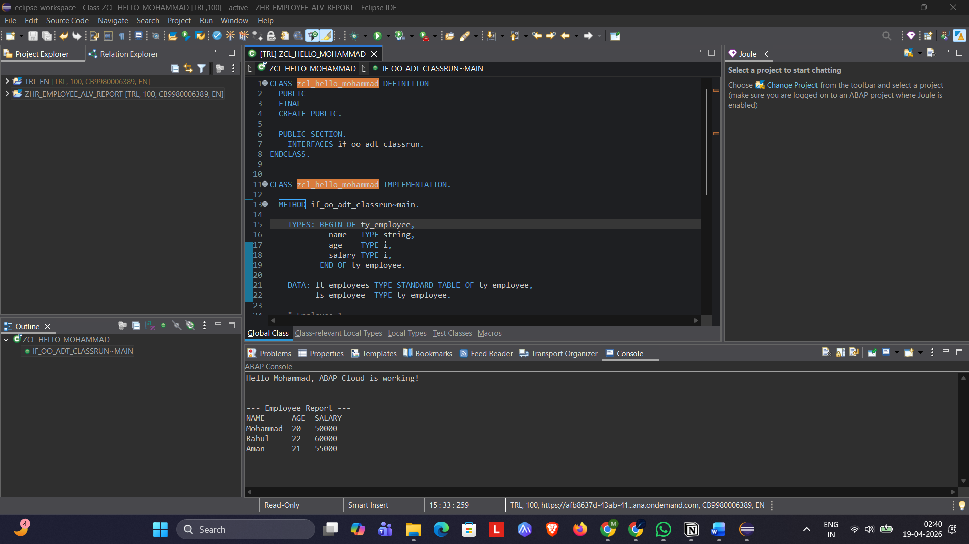
[Screenshot: ZHR_EMPLOYEE_ALV_REPORT — Selection Screen (SE38 / T-code)]

4.2 ALV Output Grid
The ALV grid displays columns: Status (traffic light), Personnel No., Employee Name, Date of Birth, Gender, Personnel Area, Sub-Area, Org Unit, Position, Job, Joining Date, Pay Grade, Annual Salary, and Currency. Rows are grouped by Org Unit with salary subtotals, and sorted by Annual Salary descending within each group.
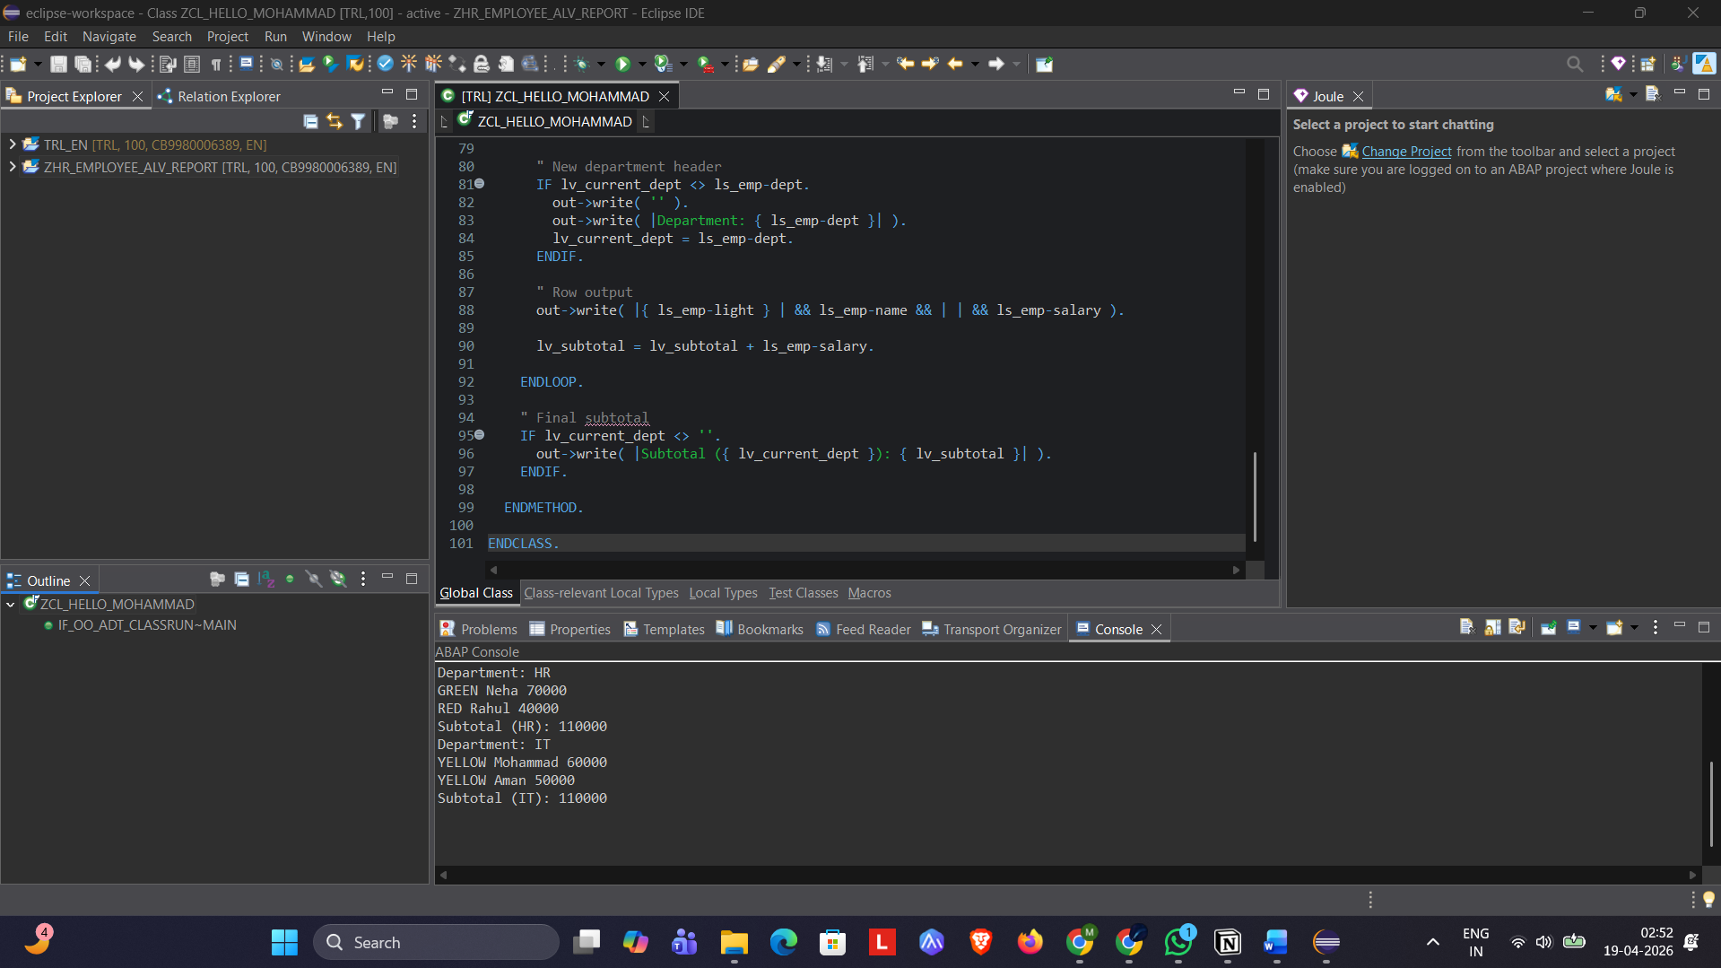
[Screenshot: ALV Grid Output — with traffic lights, subtotals, and sorted salary column]
4.3 Top-of-Page Header
The top-of-page area shows: report title, selected Personnel Area, run date, and total record count — generated via REUSE_ALV_COMMENTARY_WRITE using SLIS_LISTHEADER structures.

5. Unique Points
- Single-program consolidation of three HR infotypes into one interactive grid, eliminating the need for multiple SE16 lookups.
- Dynamic traffic-light salary benchmarking computed at runtime — no static thresholds hardcoded; average is always recalculated from the current result set.
- Modular FORM routines with DEFINE / END-OF-DEFINITION macros for field catalogue construction, keeping the code concise and maintainable.
- Dual-purpose toolbar extension: Top-N filter and PA20 drill-down work without leaving the ALV grid, improving HR analyst productivity.
- Variant management integrated into the selection screen with F4 help, allowing personalised column configurations to be saved per user.

6. Future Improvements
- Migrate to CL_GUI_ALV_GRID (OO ALV) to leverage column-level toolbar buttons, cell-level formatting, and Excel export via CL_GUI_FRONTEND_SERVICES.
- Add infotype PA0007 (Planned Working Time) and PA0041 (Date Specifications) to display contract type and probation end date alongside current data.
- Introduce a charting panel using CL_SALV_HIERSEQ_TABLE for headcount and salary distribution visualisation within SAP GUI.

7. Conclusion
Program ZHR_EMPLOYEE_ALV_REPORT demonstrates a complete, end-to-end ABAP development scenario covering selection screen design, multi-table data retrieval with performance considerations, in-memory join and computation, classic ALV grid display with layout and sorting, event-driven user interactions, and drill-down navigation. The project reflects practical HR reporting requirements and can be directly adapted for real enterprise SAP HR landscapes.

All source code is documented inline with standard SAP ABAP commenting conventions. The program is self-contained and activatable via transaction SE38 in any SAP ECC 6.0 or S/4HANA system with HR module activated.

